**Troubleshooting Lab Issues**

This article provides a brief overview of the steps to be followed when an error occurs while accessing the Videos/Course contents/ labs and quizzes.

1. Make sure you are using Google Chrome to access the labs. Our users have had more success using Google Chrome than any other browser.
2. If you are seeing the below error, then most likely you have an Ad or Javascript or popup blocker enabled. Disable Ad or Javascript blockers and try again. Our labs use javascript to display the terminal. If you are using the Brave browser, then test the labs in unblocked mode.  
   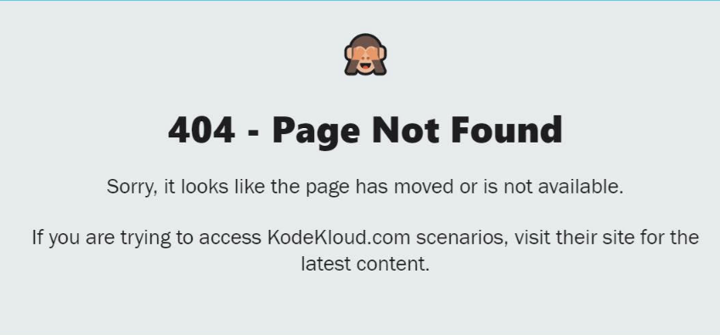
3. Check if your firewall or proxy is preventing the connection to the labs.
4. Clear the cache and cookies and try loading again.
5. Try accessing from a different network. We have seen cases before when katacoda.com is blocked in certain corporate networks. If you are accessing the labs from a corporate network, try accessing from a different network.
6. Check your internet connection. Internet connection dropping or network with low speed can cause labs to end abruptly. You must have a stable internet connection with good speed.
7. Go to [katacoda.com/embed.js](http://katacoda.com/embed.js) and make sure the connection is successful.

If you get a message similar to this when accessing the labs, please contact us at [support@kodekloud.com](mailto:support@kodekloud.com) and share the screenshot with us.

We will contact Katacoda to grant back the access/whitelist

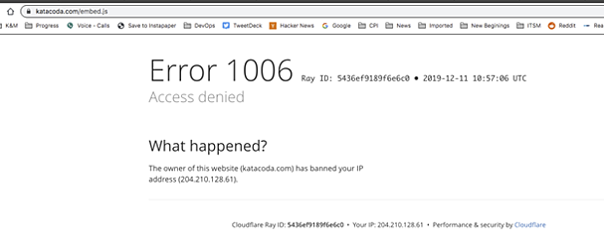

  6. Check for error messages in your browser console.

* Try to open the labs in your browser
* Right-click on the page and select Inspect  
  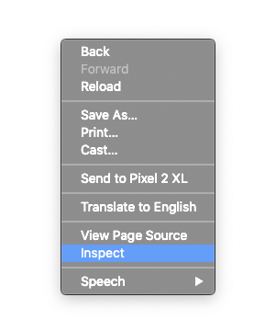
* Select Console in the window that opens and share a screenshot of the message you see there with us at support@kodekloud.com.  
    
  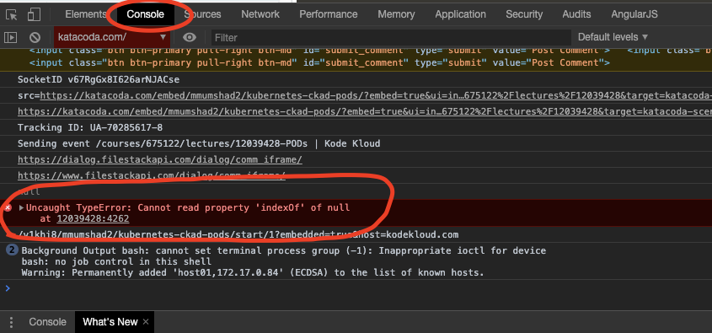

***If none of the above solves your problem do reach out to us at***[***support@kodekloud.com***](mailto:support@kodekloud.com)***and we will be happy to work with you to sort it out.***